**JAWAHAR NAVODAYA VIDYALA C J HALLI DISTT BELLARY**

WEBSITE UPDATE LINKS (PLASE OF UPLODING FILE &folders)

1. HOME---CHANGE VIDEO---ADD NEW VIDEO.

http://www.jnvballari.com/Streams.html

1. SCHOOL---STREAMS---REMOVE -ENROLMENT OF STUDENTS AS ON : 29.11.2014--ACADEMIC YEAR -2014-15

3) SCHOOL---CONTACT US---PRINCIPAL SIR NO REMOVE

4) ACADAMICS---JNVST---JNVST- 2017 & 2018 REGISTRATION

5) RESULT---SCHOOL RESULT---PWT.1 PWT.2 PWT.3

6) RESULT ---CBSE---CLASS XII AND X 2017-18.

7) ACTIVITIES---INSERT NEW TOPPER LIST 12TH AND 10th 2017-18

8) ACTIVITIES---CCA---ADD NEW PHOTOS

9) ACTIVITIES---NCC---ADD MATTER

10) INSERT THE REMOVE OLD PHOTO INSERT- NEW PHOTO

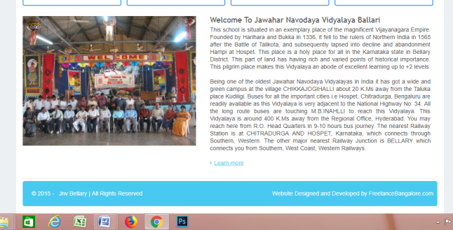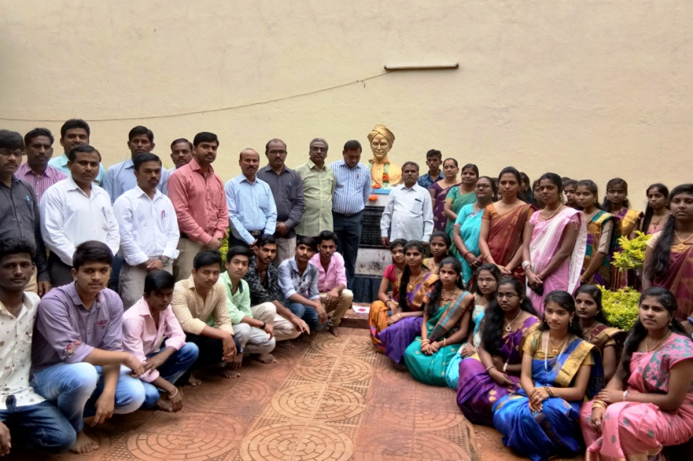

OLD PHOTO NEW PHOTO